Example N0 1:

**Input:**

using System;

namespace CONSOLEAPP07

{

class Program

{

static void Main(string[] args)

{

string firstName = "Abdullah";

string fatherName = "Muhammad Sadiq";

string emailId = "abdullahsadiq0701@gmail.com";

string contactNumber = "0312-1231231";

Console.WriteLine("-My Profile");

Console.Write("My name is: "+firstName+"\n"+"My Father name is: "+fatherName+"\n"+"MY Email ID: "+emailId+"\n"+"My Contact Number: "+contactNumber);

}

}

}

**Output:**

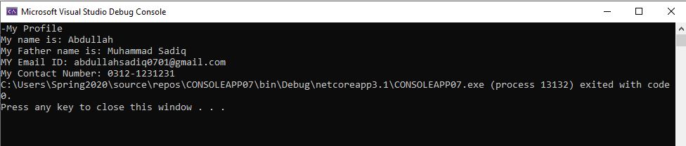Example No 2:

**Input:**

using System;

namespace CONSOLEAPP07

{

class Program

{

static void Main(string[] args)

{

Console.WriteLine("Enter your Name");

string firstName = Console.ReadLine();

Console.WriteLine("Enter Your Father Name");

string fatherName = Console.ReadLine();

Console.WriteLine("Enter Your Gmail");

string emailId = Console.ReadLine();

Console.WriteLine("Enter Your Contact Number");

string contactNumber = Console.ReadLine();

Console.WriteLine("-My Profile");

Console.Write("My name is: "+firstName+"\n"+"My Father name is: "+fatherName+"\n"+"MY Email ID: "+emailId+"\n"+"My Contact Number: "+contactNumber);

}

}

}

**Output:**

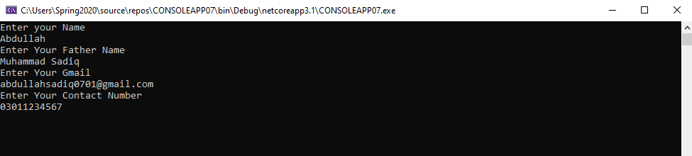

Example No 3:

**Input:**

using System;

namespace CONSOLEAPP07

{

class Program

{

static void Main(string[] args)

{

int numA = 10;

int numB = 20;

int result;

result = numA + numB;

Console.WriteLine("the sum is" + result);

result = numA - numB;

Console.WriteLine("The sub is" + result);

result = numA * numB;

Console.WriteLine("The sum is" + result);

}

}

}

**Output:**

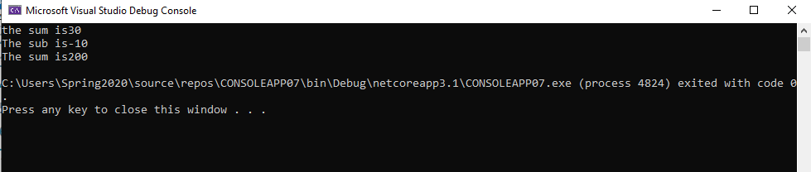

Example No 4:

**Input:**

using System;

namespace CONSOLEAPP07

{

class Program

{

static void Main(string[] args)

{

Console.WriteLine("Enter Number From 0-9");

string numAuser = Console.ReadLine();

int numA = Convert.ToInt32(numAuser);

string numBuser = Console.ReadLine();

int numB = Convert.ToInt32(numBuser);

int result;

result = numA + numB;

Console.WriteLine("the sum is" + result);

result = numA - numB;

Console.WriteLine("The sub is" + result);

result = numA * numB;

Console.WriteLine("The sum is" + result);

}

}

}

**Output:**

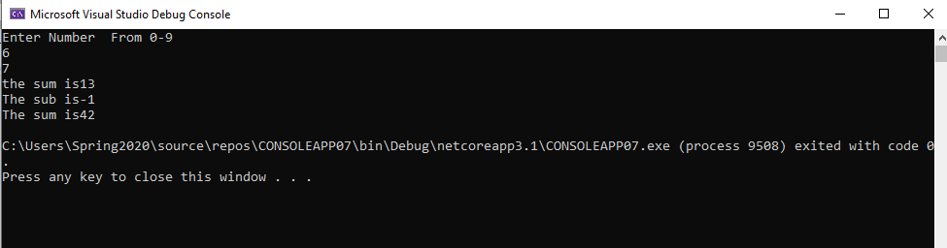

Task No 2: Write a program to display your personal information.

**Input:**

using System;

namespace My_Profile

{

class Program

{

static void Main(string[] args)

{

string Name = "Abdullah";

string fatherName = "Muhammad sadiq";

string Age = "17";

string Address = "Karachi, Pakistan";

string universityName = "Bahria University Karachi Campus";

string nicNumber = "42401-0000000-0";

string phoneNumber = "0301-0000000";

Console.WriteLine("-My Profile-");

Console.Write("My name is; " + Name + "\n" + "My Father name is :" + fatherName + "\n" + "My age is: " + Age + "\n" + "I live in " + Address + "\n" + "I am a student of " + universityName + "\n" + "My NIC Number is :" + nicNumber + "\n" + "My Mobile Phone Number is :" + phoneNumber);

}

}

}

**Output:**

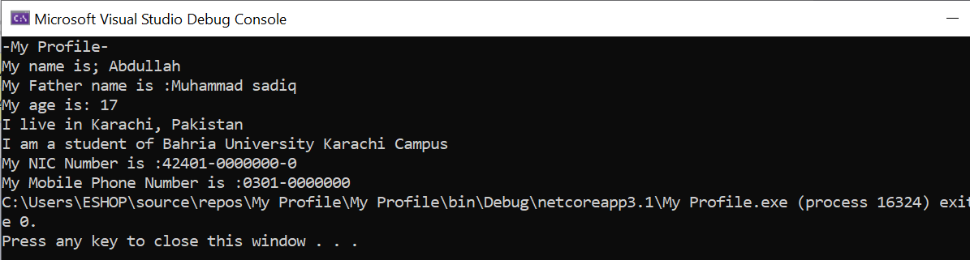**Task No 3:** Write a program to display Your inter/ matric marks sheet.

**Input:**

using System;

namespace My_Marksheet

{

class Program

{

static void Main(string[] args)

{

string physicsMarks = "93/100";

string chemistrymarks = "96/100";

string mathsMarks = "95/100";

string englishMarks = "95/100";

string urduMarks = "94/100";

string IslamiatMarks = "48/50";

Console.WriteLine("\t-Marks Sheet-");

Console.WriteLine("Subject \t Marks");

Console.Write("-Physics \t:" + physicsMarks + "\n" + "-Chemistry \t:" + chemistrymarks + "\n" + "-Maths \t:" + mathsMarks + "\n" + "-English \t:" + englishMarks + "\n" + "-Urdu \t:" + urduMarks + "\n" + "-Islamiat \t:" + IslamiatMarks);

}

}

}

**Output:**

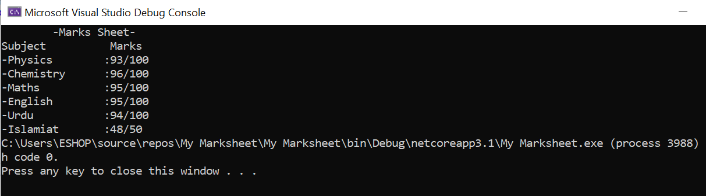

**Task No 4:** Write a C# program that displays the results of the expressions.

**Input:**

using System;

namespace Calculations_CP

{

class Program

{

static void Main(string[] args)

{

float a = 3.0F;

float b = 5.0F;

float ab = a * b;

Console.WriteLine("3.0 * 5.0 =" + ab);

float c = 7.1F;

float d = 8.3F;

float e = 2.2F;

float cde = c * d - e;

Console.WriteLine("7.1 * 8.3 - 2.2 = " + cde);

float f = 3.2F;

float g = 6.1F;

int h = 5;

float we = f / (g * h);

Console.WriteLine("3.2 / (6.1 * 5) = " + we);

int t = 15;

int o = 4;

int q = t / o;

Console.WriteLine("15 / 4 = " + q);

float p = 0.15F;

float l = p * o;

Console.WriteLine("!5% of 4 = " + l);

int j = 3;

int y = 6;

int r = h * j - (y * o);

Console.WriteLine("5 * 3 - (6 * 4) = " + r);

}

}

}

**Output:**

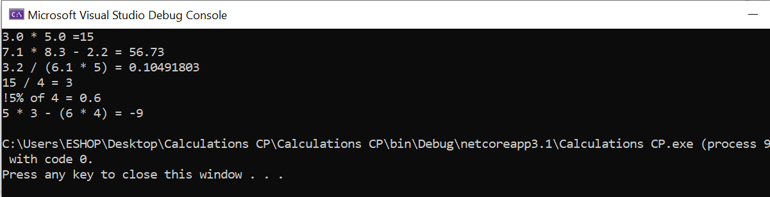

**Task No 05:** Calculate the temperature in Celsius using integer values.

**Input:**

using System;

namespace Abdullah_Sadiq_CP_Lab_3

{

class Program

{

static void Main(string[] args)

{

Console.WriteLine("Enter Temperature in Fahrenheit");

int f = Convert.ToInt32(Console.ReadLine());

int c = (f - 32)*5/9;

Console.WriteLine("The Temperature in Celcius is {0}", c);

}

}

}

**Output:**

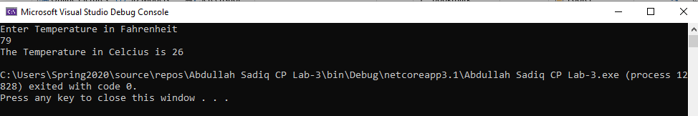

**Task No 06:** Calculate the area of Circle.

**Input:**

using System;

namespace Abdullah_Sadiq_CP_Lab_3

{

class Program

{

static void Main(string[] args)

{

int r = 8;

Console.WriteLine("Radius = 8cm");

Console.WriteLine("Pie = 22/7");

float a = r * r * 22 / 7;

Console.WriteLine("Area of Circle is {0}", a);

}

}

}

**Output:**

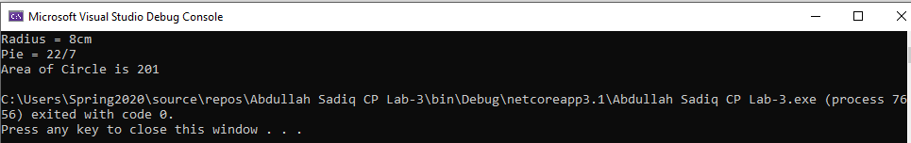

**Task No 07:** Display the result of the expression: ((( a + b) * (c * e * d)) – e)/f

**Input:**

using System;

namespace ConsoleApp1

{

class Program

{

static void Main(string[] args)

{

//(((a + b) * (c * e * d)) – e)/ f

int a, b, c, d, e, f;

a = 2; b = 3; c = 5; d = 4; e = 7; f = 1;

double result1 = (((a + b) * (c * e * d))-e);

double result2 = result1 / f;

Console.WriteLine("Given Expression\n(((a + b) * (c * e * d)) – e)/f\n\n Let\na = 2, b = 3, c = 5, d = 4, e = 7, f = 1,\n\nThe Result of the Expression Is {0}", result2);

}

}

}

**Output:**

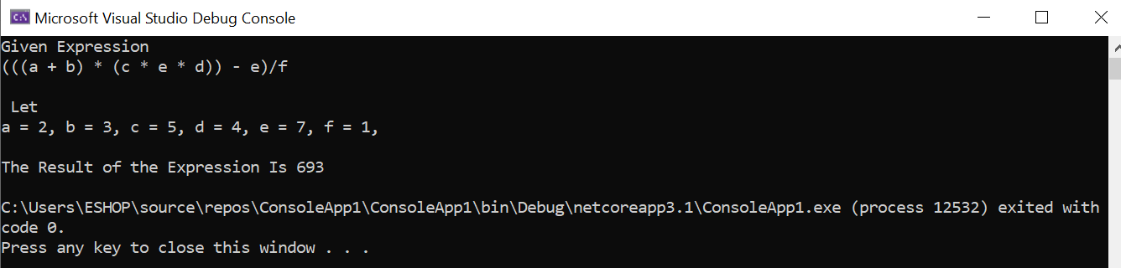

**Task No 08:** Write a program and print the output of first equation of the motion. For values take input from user. (vf=vi+at).

**Input:**

using System;

namespace Home_Task_07

{

class Program

{

static void Main(string[] args)

{

Double vf, vi, a, t;

Console.WriteLine("Enter initial Velocity: ");

vi = Convert.ToDouble(Console.ReadLine());

Console.WriteLine("Enter the acceleration: ");

a = Convert.ToDouble(Console.ReadLine());

Console.WriteLine("Enter time in seconds: ");

t = Convert.ToDouble(Console.ReadLine());

vf = vi + a * t;

Console.WriteLine("The final velocity of vehicle after {0} second is {1} m/s", t, vf);

}

}

}

**Output:**

